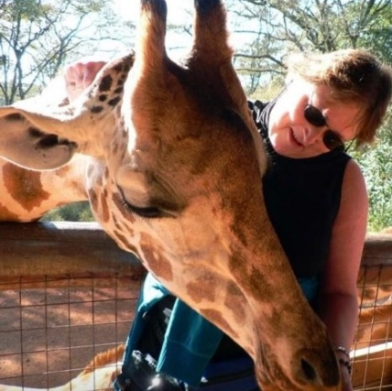African safari packing tips

The most practical items to pack for safari are:

Soft-sided bag like a duffle required for small aircraft

Khaki, green, beige and neutral color clothing

Shirts with long sleeves (even in summer, as protection from the sun and mosquitoes)

T-shirts

Shorts or a light skirt

Jeans or safari trousers for evenings and cooler days

Jackets and sweaters are recommended for early morning and evening game drives

Lightweight water-proof jacket

Swim and beachwear if you like pools

Comfortable walking shoes and socks

Sun block, sunglasses, hat, moisturizer and lip-salve

Strong insect repellent like Mosi Guard ([www.mosi-guard.com)](http://www.mosi-guard.com/)

Binoculars and camera equipment (watch your weight on equipment. Most of your internal flights will have a very strict weight limit of 11 pounds for carry-on.)

Really good zoom lens

Make sure you play with your camera before you go!

Linda de Sosa 2814601090 lindadesosa@travelXperts.com